Banyule Cubs Founders Day 2025

Bike Ride

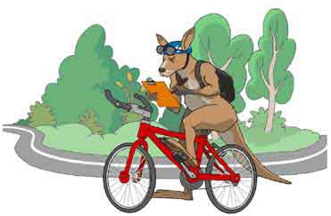

**Sunday 23rd February 2025**

***Meeting time 10.00***

***Riding from:***

CT Barling Reserve

Entry from the City or Southbound side of Plenty Road

Reservoir

***Riding to:***

Sills Bend (NOT Possum Hollow – Sills Bend is further around the oval)

Part of Warringal Parklands

Heidelberg

Where we will meet up with the Scout Section for a Sausage sizzle

Cubs please wear uniform & helmet

* Operoo form is required – please ensure it’s up to date!

Please pack:

* Snacks
* Water bottle
* Medications
* Sunblock / insect repellent

***No Scooters or bikes with training wheels***

*At the end of the ride.*

*This is where we meet up with the Scout Section*

Taking part in a sausage sizzle, drink, along with a zooper dooper

There is no charge for this.

Adult/Youth Helpers are welcome to attend.

**Cubs collection at 1.30 pm from Sills Bend**

For Catering & Operoo Purposes:

***PLEASE ENSURE you RSVP*** to Wayne/Akela by Saturday 15th February

Overview of the map

